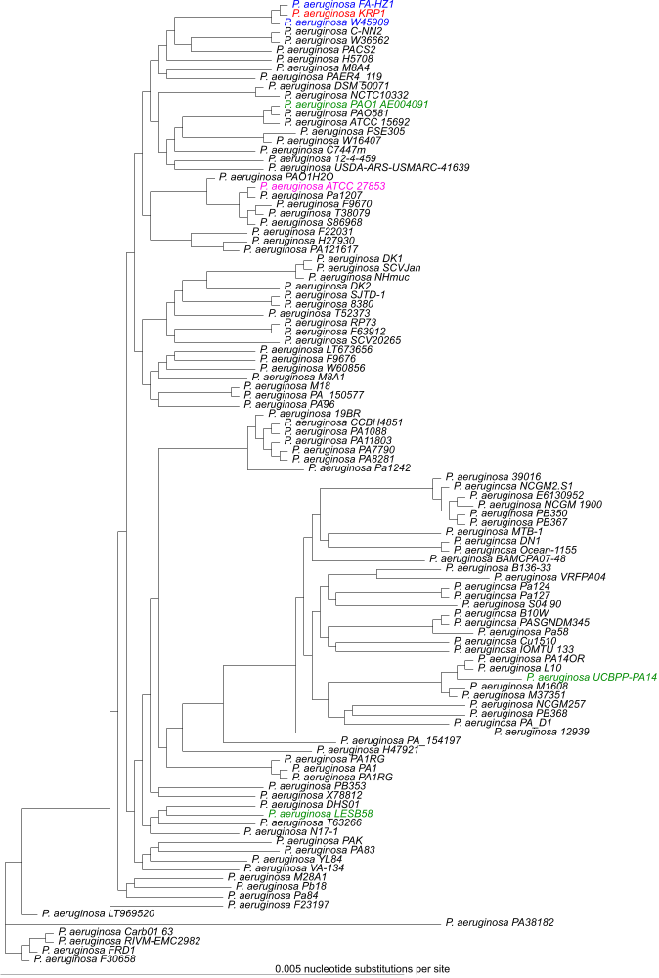
Figure S1: Phylogenetic tree of 105 fully sequenced P. aeruginosa strains.
P. aeruginosa KRP1 (red), the two closest relatives P. aeruginosa FA-HZ1 and W45909 (blue), the model strain PAO1, the common research strain PA14 and the potent virulent strain LESB58 (green) and the strain ATCC 27853 (pink), which showed the highest 16S rRNA similarity in the original publication from K Rabaey, N Boon, SD Siciliano, M Verhaege and W Verstraete [1], are highlighted. The tree was calculated using the EDGAR platform [2, 3] out of a core of 2,567 genes per genome, which transcribe to 780,580 aa-residues per genome.

1. Rabaey K, Boon N, Siciliano SD, Verhaege M, Verstraete W: Biofuel cells select for microbial consortia that self-mediate electron transfer. Appl Environ Microbiol 2004, 70(9):5373-5382.
2. Blom J, Albaum SP, Doppmeier D, Pühler A, Vorhölter F-J, Zakrzewski M, Goesmann A: EDGAR: A software framework for the comparative analysis of prokaryotic genomes. BMC Bioinf 2009, 10(1):154.
3. Blom J, Kreis J, Spänig S, Juhre T, Bertelli C, Ernst C, Goesmann A: EDGAR 2.0: an enhanced software platform for comparative gene content analyses. Nucleic Acids Res 2016, 44(W1):W22-W28.

